Contents

Game Rules 2

Card Values 2

Ace Value 2

Game Menu 3

In Game 5

Your turn 5

Dealer’s turn 9

# Game Rules

The actual goal of this game is to get as close to 21 as possible without going over. If you go over 21, you go “bust” which makes you automatically lose.  
More information can be found at: <https://en.wikipedia.org/wiki/Blackjack>

## Card Values

Cards 2-10 have the value of their number.  
A Jack, Queen and a King all have a value of 10.

### Ace Value

An ace card, however, Is a special case, it can be valued at either 1 or 11. Whether or not the ace is a 1 or 11 is calculated by the game. If the ace is 11 (as it is in figure 4), and you get some more cards which puts your deck at a value over 21 (which would cause you to go bust and lose the game), the ace will change to a 1, because it is more beneficial for the ace to be a 1.  
Due to this, it is important to take note of the aces you have in your deck, as in figure 4, you would not have to worry about getting a king, as it will cause your ace to change its value to 1, as this is more beneficial.  
There is an example of this in figure 5.

# Game Menu

When you first start the game, you are presented with the game menu, which has the option to either quit the game, or play the game. The main menu is shown in figure 1.

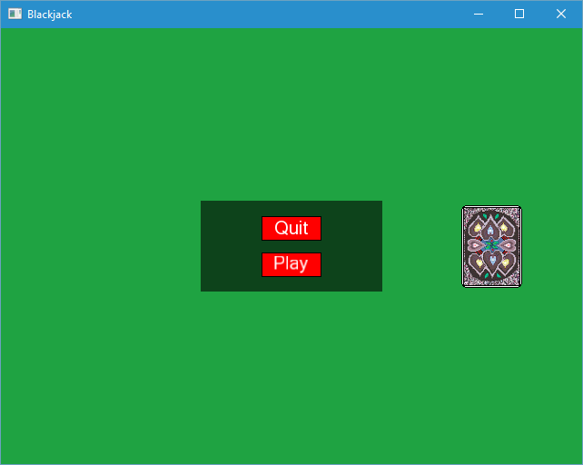

*Figure 1: Main menu.*

By moving your mouse over the “Play” button, the button will light up.   
If you press and release your mouse while hovering your mouse over this button, the game of blackjack will being. This is shown in figure 2.

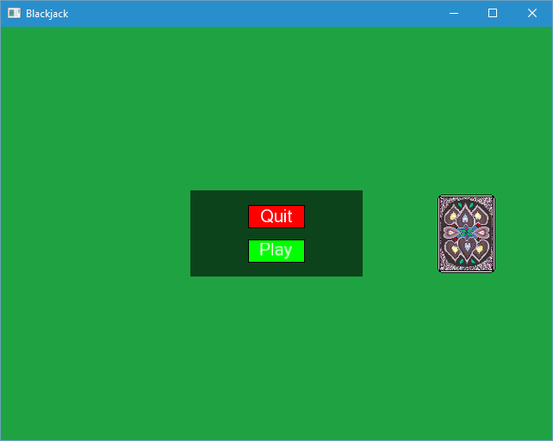

*Figure 2: Pressing play.*

# In Game

## Your turn

Once you’re in the game after pressing the “Play button”, your turn will begin!  
Your turn begins by being dealt two cards, these cards will appear from the right hand side of the screen, and slide to where your deck is.

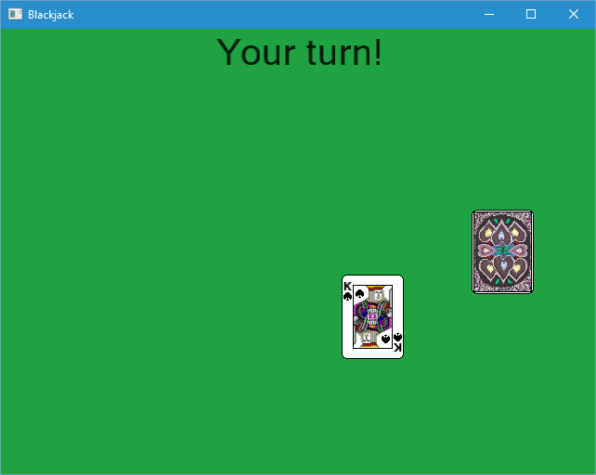

*Figure 3: Being dealt cards.*

Once you’ve been dealt your two cards, you will have the option to Hit or Stand, if you decide to press “Hit”, then you will be given another card from the main deck. This will have the same animation as when you were being dealt your first cards. By pressing hit, you can attempt to get your deck value as close as possible to 21.

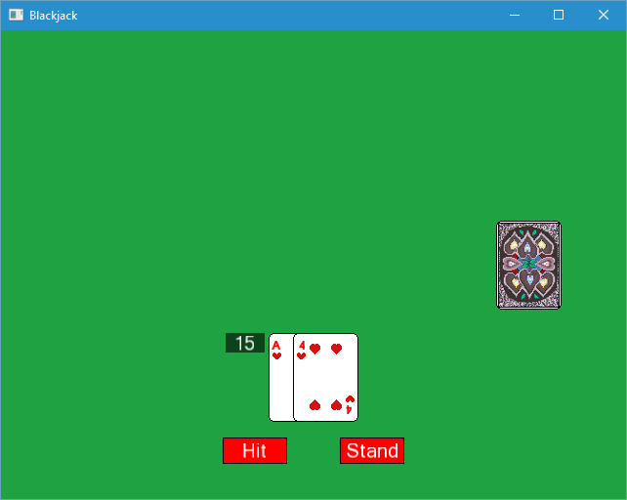

*Figure 4: Your turn.*

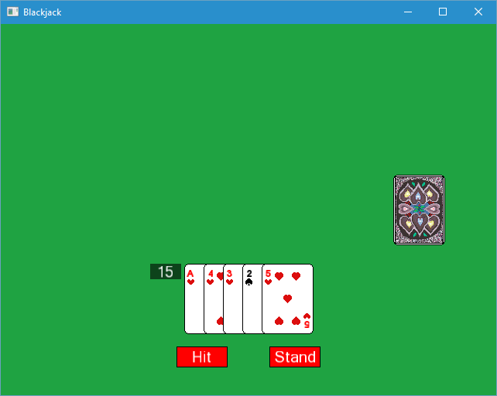

*Figure 5: Ace changing value.*

In figure 5 there is an example of when an ace changes its value. The deck in figure 5 deck has some extra cards than the deck in figure 4, it has a 3, 2 and a 5, which in combination give a value of 10. Even though an extra value of 10 is added onto the original value of 15 (in figure 4), the player is still safe even though this would imply a total value of 25 (causing the player to go bust). This is because as soon as this deck is valued at over 21, the ace in the deck changes to a 1 (the aces changes to a hard ace), so now the deck is worth 15, instead of the 25 it would be valued at if the ace was still worth 11.

Once you’re happy with your cards, and your deck’s value, you can decide to Stand.  
Pressing “Stand” will end your turn, and allow the dealer to start their’s

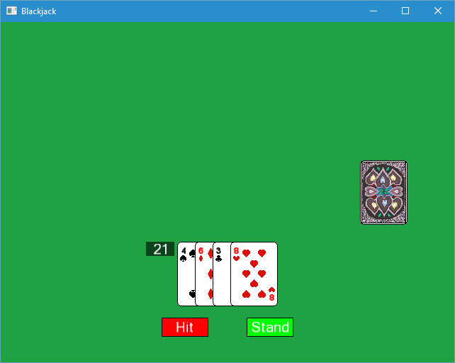

*Figure 6: Pressing stand.*

## Dealer’s turn

When the dealers turn has started, you will be unable to press any buttons until they are done.  
The dealer will first be dealt their first two cards, and then they will continuously hit until they either go bust, or beat your deck.

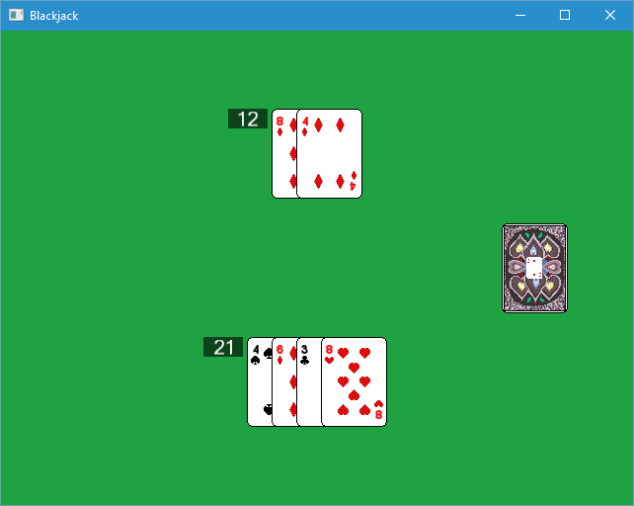

*Figure 7: Dealer’s turn.*

Once the dealer has either beaten you, or gone bust (gone bust in figure ), or if you go bust before the dealer’s turn, then you will be presented with the game menu again, where you can either choose to quit the game, or to continue playing.  
While in the menu, you can still see the results of the previous match, but as soon as you press “Play”, the previous match will be gone, and the next match will begin.

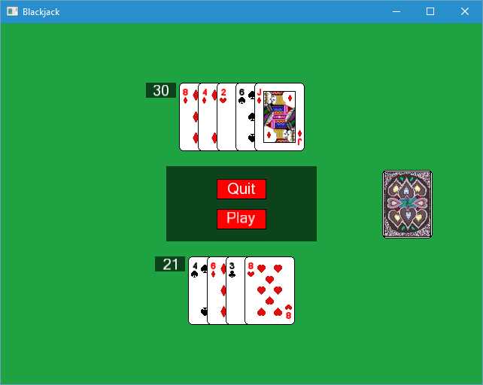

*Figure 8: Game ending, return to the main menu.*